Product | : Manually Operated Retractable Roof
Client | : Transformer & Rectifiers (India) Ltd.
Mfg. Year | : 2024-25.

DESIGNED, DEVELOPED & MARKETED
BY

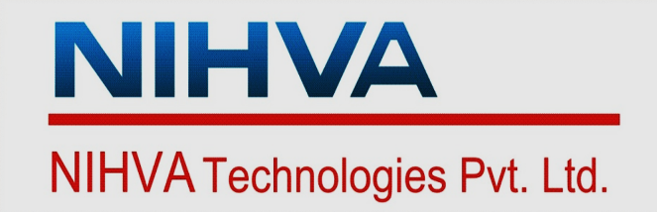

G-BLOCK, 1ST FLOOR, THERMAX CHOWK
MIDC, ABOVE RENAULT SHOWROOM
CHINCHWAD, PUNE-411019

TEL.NO. - +912066304033
EMAIL:- info@nihva.com
www.nihva.com

 | Manually Retractable Roof
Size | : W 8700mmX L 23400mmX H3500mm
No of panel | : 08 Nos
Client | : Transformer & Rectifiers (India) Ltd.
Product | : Manually Operated Retractable Roof Tanking Pit Unit.

About.:

Retractable roof modules in existing constructions consist of one or two roof panels driven by one drive unit. Usually, the Class II mechanisms used are in the form of a four-bar linkage, whose task is to absorb sudden surges in wind. The pre-set objective sought new solutions that would allow the implementation of roof modules with an increased number of panels, for example, three or more. The movement of the mechanisms is strictly defined.
Manually operated retractable roofing systems encompass a manual force that is used to retract or expand the roof at the push of human.
● Frame structure
● Roofing Material
● Motorized Mechanism
● Tracks and Guides
● Sensors
● Safety Features

DESPATCH & UN-LOADING.:

1. Loading, for dispatch, will be our responsibility. On receipt of the Retractable Roof material at site, please check and ensure that there is no physical damage to the equipment.
2. While unloading the equipment from the transporting vehicle, please ensure to use slings with rated capacity higher than the gross weight of the Stationary lift in packed condition.
3. Slings MUST be hooked ONLY at specified positions. These positions are indicated and marked with a figure of ‘HOOK’. Improper sling position or improper slinging could cause damage to the equipment.

B. ORDERING OF SPAERE.:

1. When ordering for spare, please specify the following in your Purchase Order.
- Equipment Name
- Model Number
- Equipment Serial No.
- Part name / Description
- Part Number
- Quantity required
- Delivery period / time
- Mode of dispatch

This would avoid ambiguity and help us serve you better.

C. INTRODUCTION.:

Established in 2012 in Pune (Maharashtra, India). We are the leading solution Provider for Residential and commercial buildings as well as Industries.
SHIVAAH is a prominent brand of NIHVA Technology Pvt. Ltd.
At “SHIVAAH,” we specialize in offering comprehensive solutions for Residential and commercial buildings. Our involvement in any project begins with a throughout understanding of the requirements, functionality, and design.
Leading to the development of a customized solution, followed by expert installation and commissioning.
We are committed to providing ongoing service support that goes beyond our initial contractual obligations.

D. PRINCIPLE.:

Retractable Roof systems is designed for homes, bungalows, villas, apartments, swim centers, hotels, restaurants, hospitals, shopping malls, offices and warehouses. This design adds luxury by allowing partial sunlight when entering the site during the day and a view of the sky at night. Retractable Roof can be operated in a variety of ways, including folding roof, sliding roof, telescopic roof, one-dimensional, two-dimensional, vertical lift and horizontal lift.

E. STEP.:

1)Assemble main sections
2)Install Floor Track
3)Install main sections
4)Install side sections
5)Install accessories, Sealing treatment.

F. USP OF RETRACTABLE ROOF.:

1)Use of MS tube for panel structure.

2)Imported Polycarbonate sheet.

3)UV-A & UV-B ray protection.

4)Italian/ German make motor with remote control.

5)High heat resistant EPDM gasket to make the system leak-proof.

6)Stainless steel parts & fasteners.

7)LED light system can be provided as per requirement.

8)RAL Powder coating finish as per requirement.

9)No need of any license from municipal authorities for terrace roofing’s since it is completely retractable.

10)Operation:
1.Remote.
2.Push button.
3.Manual.

G. PRE – OPERATING INSTRUCTIONS.:

- Ensure joint leakage.
- Ensure proper location of Retractable Roof.
- Ensure Manual mode of Retractable Roof.
- Ensure Interlocking of Panel.

H. CLEANING INSTRUCTIONS.:

- First Spray water on Manually Operated Retractable Roof.
- Clean the Retractable Roof with Micro Fabric cotton to avoid scratches on profile and sheet.
- At time of cleaning of Retractable Roof hang safety belt.
- Avoid walking on sheet. You can walk on support member instead of sheet.

I. Drawing.:

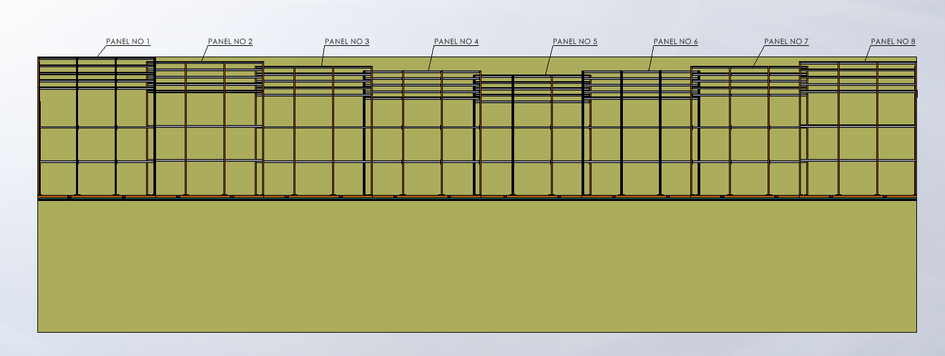
SIDE VIEW

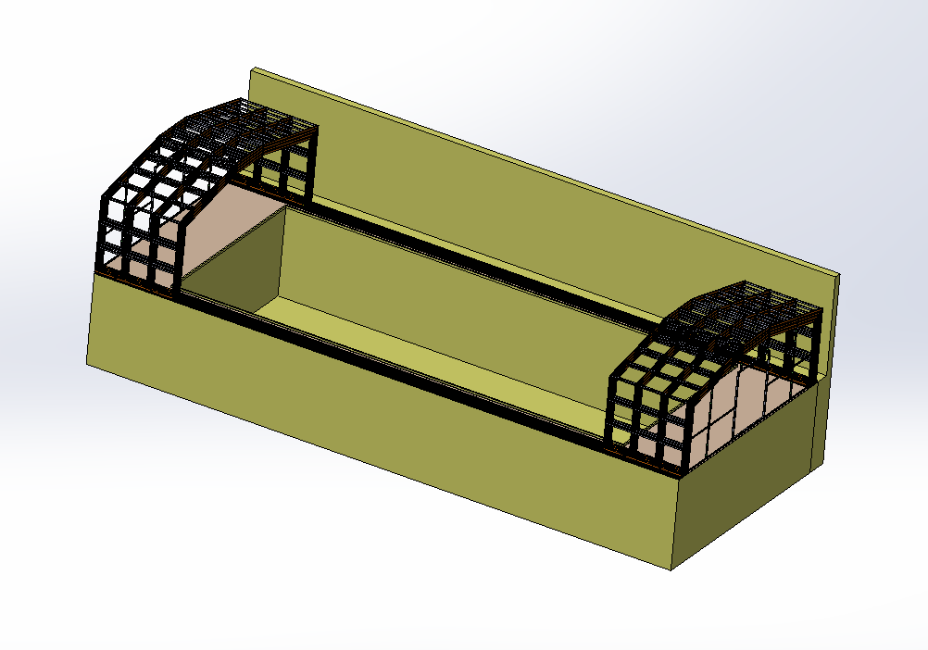
Open Position ISO-Metric View
Opening-77%
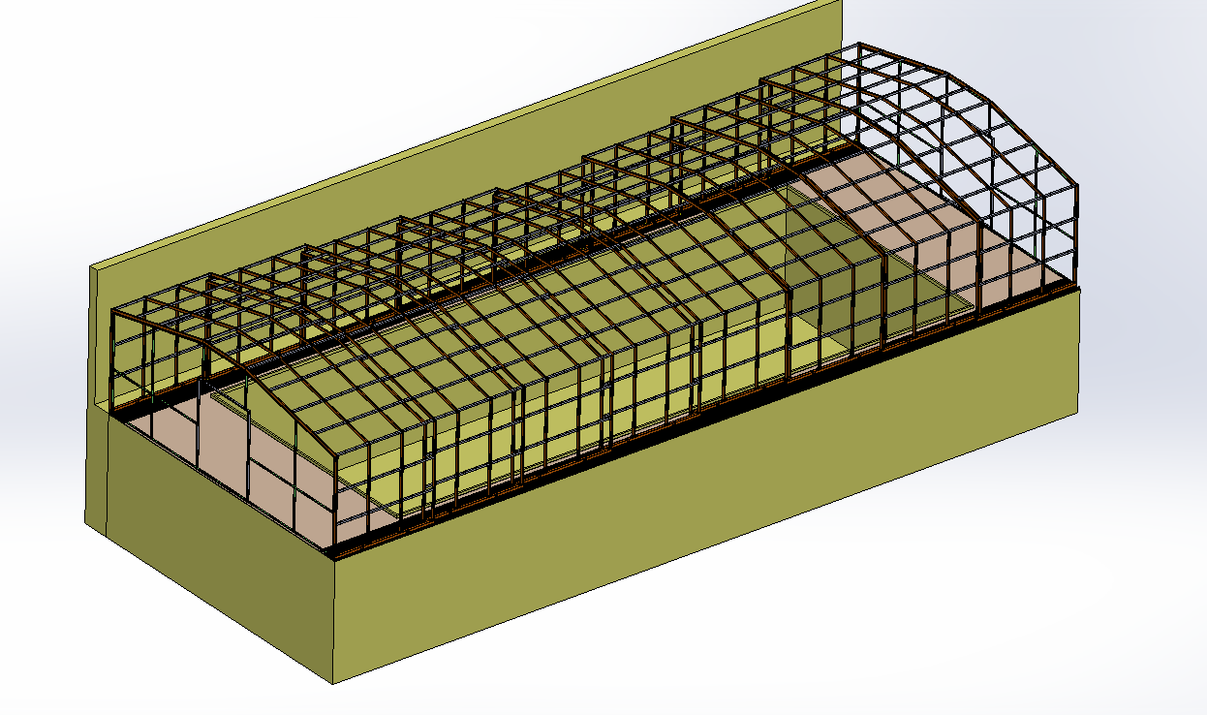
Close Position ISO-Metric View

J. ROUTINE MAINTENANCE AND LUBRICATION.:

These recommendations are applicable to the Retractable Roof considering average daily usage of 05 to 10 times. If it is used more frequently, the same time intervals for the maintenance should be adjusted accordingly.

MONTHLY:
- Grease the Track.
- Check Tightening of Bolt.
- Check the alignment of Roof.

How to operate the Manually Operated Retractable Encloser
The Retractable system gets activated, ensure the unlocking of panel.

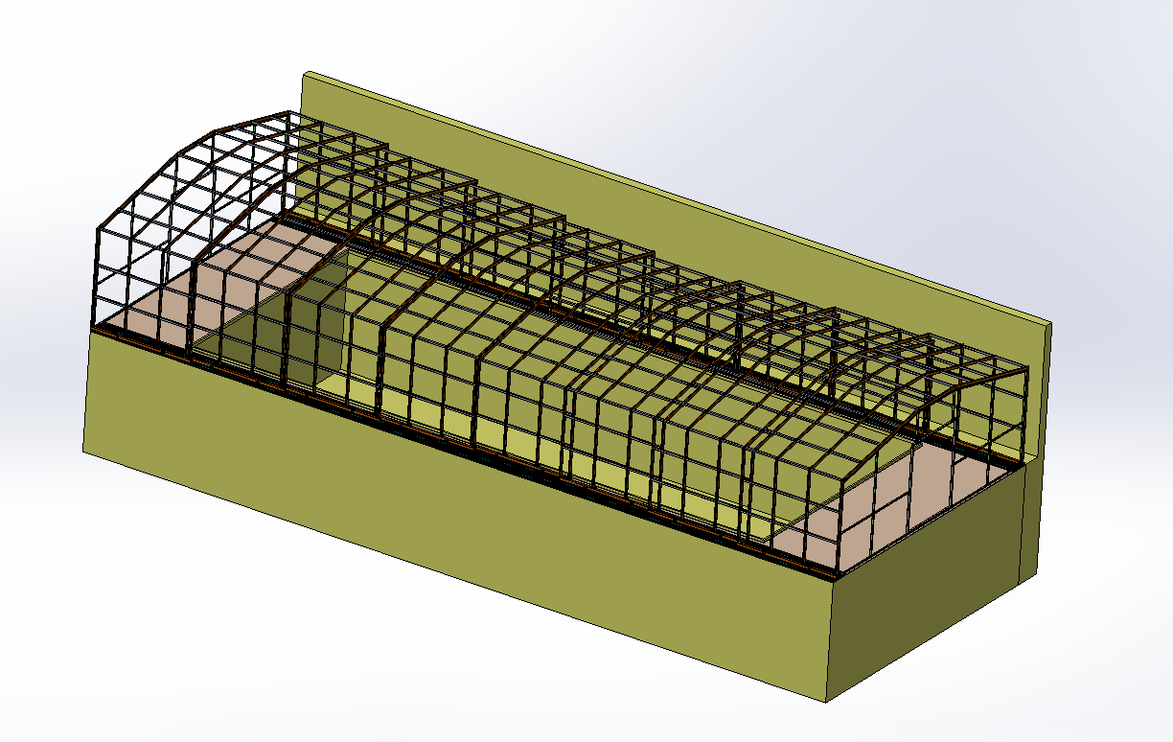

- Roof open.: Push the panel from middle position to both sides up to the fix panel.
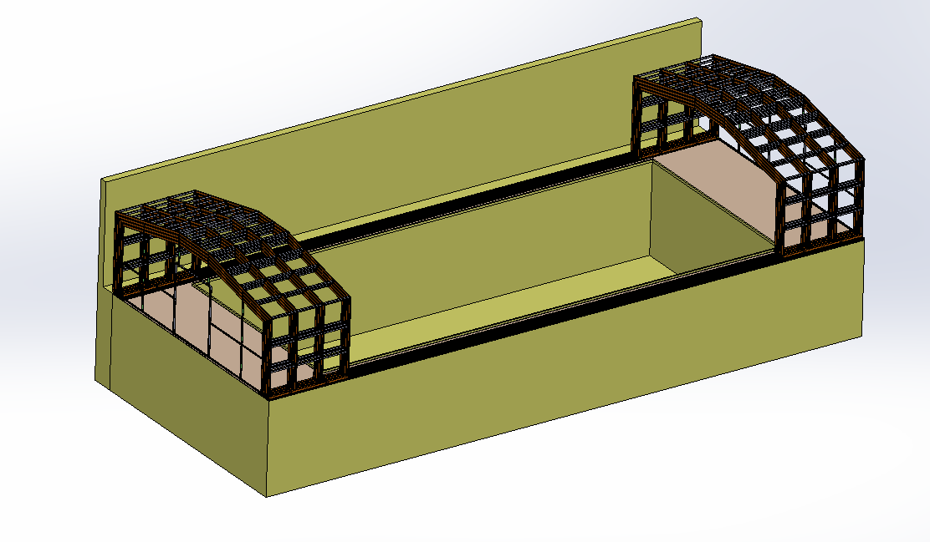

- Deck Close.:
Push the panel from fix panel position to both sides upto the center.
Guide Roller wheels should rotate easily and be free from dirt / grime.

- Warning:

Incorrect or improper use of this product can cause damage to persons, animals or properties.

More than 3 to 4 persons never allow to stand on Retractable Roof panel.

Guide Roller wheels should rotate easily and be free from dirt / grime.
Make sure that Retractable Roof end stopper is each end (Both End) of the track to prevent the panel travelling off the track.

Never allow anyone to Stand on the Retractable Roof while moving.

Ensure power plug is disconnected from the power socket during cleaning or maintenance.

